MATHEMATICS

READING BASIC FORMULAE

FORMULA (Sg) – FORMULAE/FORMULAS (Pl)

- BASIC MATHEMATICAL PROCESSES:

Sign Noun Verb

+ (plus) addition add

- (minus) subtraction subtract

X (multiplied by/times) multiplication multiply

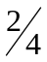(divided by) division divide

= (equals/is/is equal to)

TYPES OF BRACKETS

- 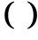 brackets

- 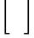 square brackets

-  curly brackets

LETTERS

ABC – capital letters, ex. capital A, capital B, capital C.

def – small letters, ex. small d, small e, small f.

FRACTIONS

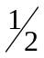 one half

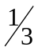 one third

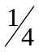 one fourth

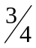 three fourths

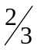 two thirds

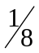 one eighth

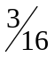 three sixteenths

READ OUT THESE FORMULAE

1. 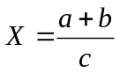

2. 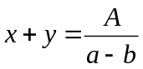

3. 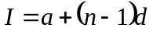

4. 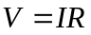

5. 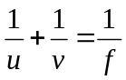

6. 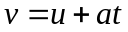

7. 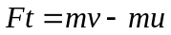

8. 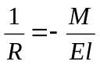

9. 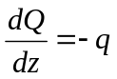

10. 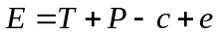

MORE SYMBOLS AND VALUES:

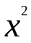 x to the power of two (x to two/x squared)

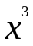 x to the power of three (x to three/x cubed)

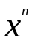 x to the power of n (x to n)

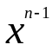 x to the power of n minus one

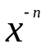 x to the power of minus n

 square root of x

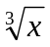 cube root of x

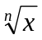 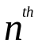root of x

- Read out these values and equations:

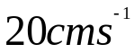
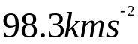
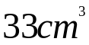
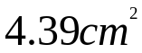
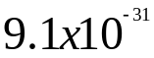
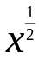
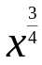
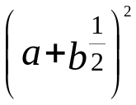
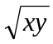
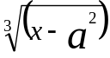

- Practice reading these expressions:

1. 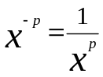
2. 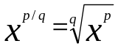

3. 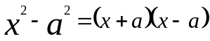

4. 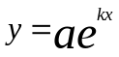

5. 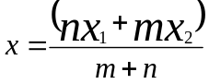

6. 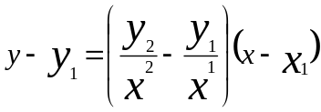 subscript

7. 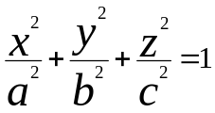

8. 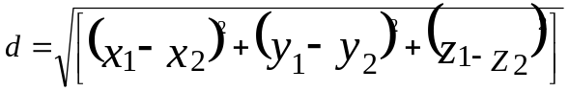

9. 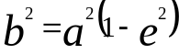

10. 